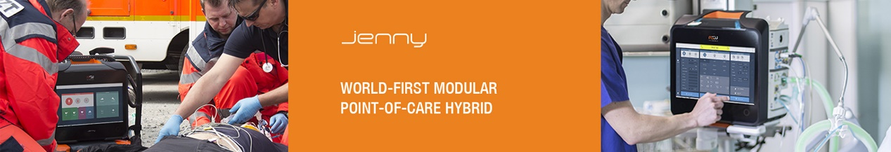



**Jenny® Cleaning**

Cleaning and disinfection after each patient application

**1.** Turn Jenny® power off and remove mains cable from the Docking Station before

cleaning.

**2.** Extract the operational battery to clean it separately.

**3.** Completely remove all modules attached to the Docking Station to clean them

separately.

**To disinfect Jenny®**

The following components and accessories must be disinfected before connecting a new patient to the device.

The following disinfection agents can be used:

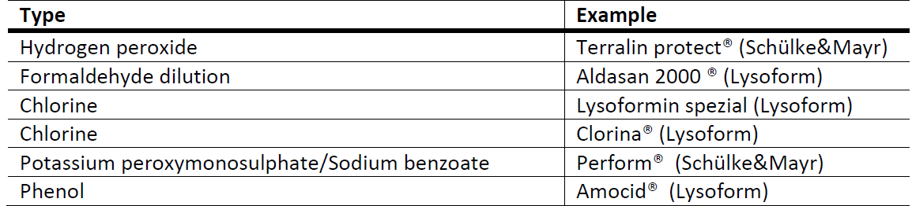

**NOTE:**

MS Westfalia recommends only the cleaning and disinfection products listed by the

Robert Koch-Institute.